**Week 7-Solutions(ReactJSHOL)**

1) **(ReactJS-HOL-9)Displaying Player Data with Map, Arrow Functions, and Destructuring**

**File name:ListOfPlayers.js**

import React from 'react';

const ListofPlayers = () => {

const players = [

{ name: 'Virat', score: 95 },

{ name: 'Rohit', score: 85 },

{ name: 'Dhawan', score: 45 },

{ name: 'Pant', score: 60 },

{ name: 'Iyer', score: 75 },

{ name: 'Hardik', score: 50 },

{ name: 'Bumrah', score: 80 },

{ name: 'Shami', score: 67 },

{ name: 'Ashwin', score: 72 },

{ name: 'Jadeja', score: 90 },

{ name: 'Kuldeep', score: 55 }

];

const playerList = players.map((player, i) => (

<li key={i}>{player.name} - {player.score}</li>

));

const below70 = players.filter(player => player.score < 70);

return (

<div>

<h2>All Players</h2>

<ul>{playerList}</ul>

<h3>Players with Score Below 70</h3>

<ul>

{below70.map((player, i) => (

<li key={i}>{player.name} - {player.score}</li>

))}

</ul>

</div>

);

};

export default ListofPlayers;

**File name:IndianPlayers.js**

import React from 'react';

const IndianPlayers = () => {

const oddTeam = ['Virat', 'Pant', 'Hardik', 'Ashwin', 'Kuldeep'];

const evenTeam = ['Rohit', 'Dhawan', 'Iyer', 'Bumrah', 'Shami', 'Jadeja'];

const [captain, viceCaptain, ...restOdd] = oddTeam;

const [opener1, opener2, ...restEven] = evenTeam;

const T20players = ['Virat', 'Rohit', 'Pant'];

const RanjiPlayers = ['Pujara', 'Rahane', 'Saha'];

const merged = [...T20players, ...RanjiPlayers];

return (

<div>

<h2>Odd Team Players</h2>

<p>Captain: {captain}</p>

<p>Vice Captain: {viceCaptain}</p>

<p>Rest: {restOdd.join(', ')}</p>

<h2>Even Team Players</h2>

<p>Opener 1: {opener1}</p>

<p>Opener 2: {opener2}</p>

<p>Rest: {restEven.join(', ')}</p>

<h3>Merged Players (T20 + Ranji)</h3>

<ul>

{merged.map((p, i) => <li key={i}>{p}</li>)}

</ul>

</div>

);

};

export default IndianPlayers;

**File name:App.js**

import React from 'react';

import ListofPlayers from './components/ListofPlayers';

import IndianPlayers from './components/IndianPlayers';

function App() {

const flag = true; // Change to false to test IndianPlayers

return (

<div className="App">

<h1>🏏 Cricket App</h1>

{flag ? <ListofPlayers /> : <IndianPlayers />}

</div>

);

}

export default App

**Output:**

**When flag=true**

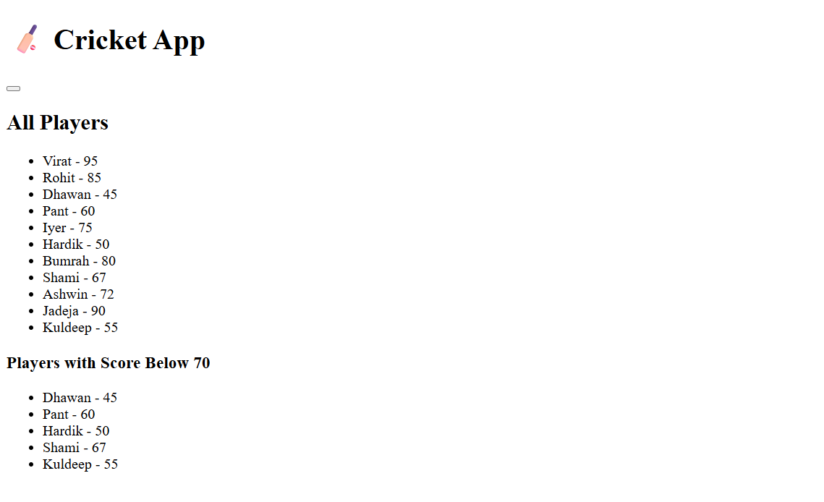

**When flag=false**

2**)(ReactIS-HOL 10) Office Space Rental Listing with Conditional Inline Styling**

**File name:App.js**

<!DOCTYPE html>

<html lang="en">

<head>

<meta charset="UTF-8" />

<meta name="viewport" content="width=device-width, initial-scale=1.0"/>

<title>Office Space Rental App</title>

<style>

body {

font-family: Arial, sans-serif;

padding: 20px;

}

h1 {

text-align: center;

}

.office-card {

border: 1px solid #ccc;

border-radius: 8px;

margin-bottom: 20px;

padding: 15px;

box-shadow: 0 0 10px rgba(0,0,0,0.1);

}

.office-img {

width: 250px;

height: 120px;

object-fit: cover;

border-radius: 4px;

display: block;

margin: 0 auto 15px auto; /* Center the image */

}

.rent {

font-weight: bold;

}

.red {

color: red;

}

.green {

color: green;

}

</style>

</head>

<body>

<h1>🏢 Office Space Rental App</h1>

<div id="app"></div>

<script>

const offices = [

{

name: "Orchid Tech Park",

rent: 55000,

address: "Whitefield, Bangalore",

image: "office.jpg"

},

{

name: "Sunshine Towers",

rent: 75000,

address: "Gachibowli, Hyderabad",

image: "office.jpg"

},

{

name: "Millennium Plaza",

rent: 62000,

address: "MG Road, Pune",

image: "office.jpg"

}

];

const app = document.getElementById('app');

offices.forEach((office) => {

const card = document.createElement('div');

card.className = 'office-card';

card.innerHTML = `

<img src="${office.image}" alt="${office.name}" class="office-img" />

<h2>${office.name}</h2>

<p><strong>Address:</strong> ${office.address}</p>

<p><strong>Rent:</strong>

<span class="rent ${office.rent < 60000 ? 'red' : 'green'}">

₹${office.rent}

</span>

</p>

`;

app.appendChild(card);

});

</script>

</body>

</html>

**Output:**

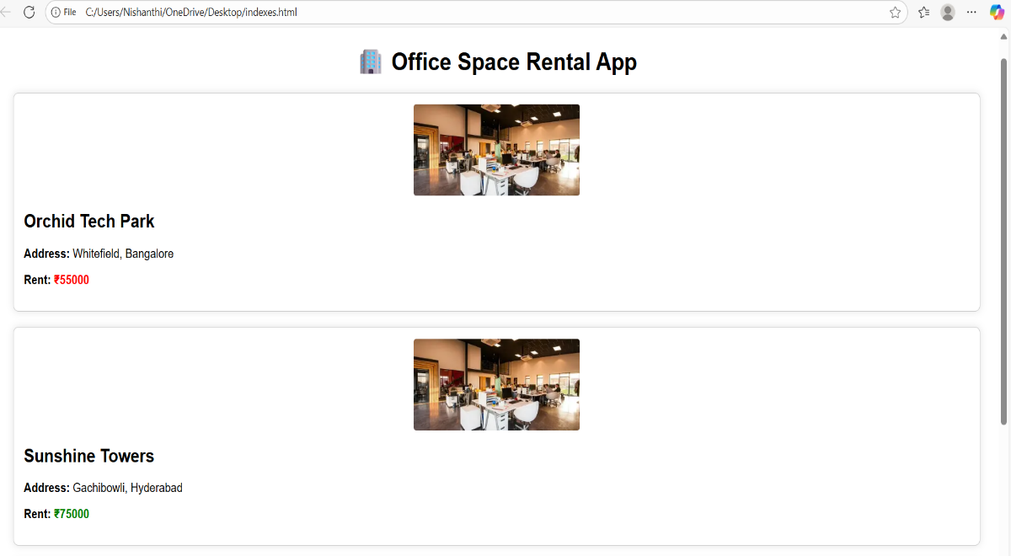

**3)(ReactJS-HOL 11) React Event Handling and Currency Conversion Lab using Synthetic Events and Event Handlers**

**File name:EventExamples.js**

import React, { Component } from 'react';

class EventExamples extends Component {

constructor(props) {

super(props);

this.state = {

count: 0,

message: '',

};

}

increment = () => {

this.setState({ count: this.state.count + 1 });

}

sayHello = () => {

alert("Hello! You clicked Increase button.");

};

handleIncrement = () => {

this.increment();

this.sayHello();

};

decrement = () => {

this.setState({ count: this.state.count - 1 });

};

sayWelcome = (msg) => {

alert(msg);

};

handleSyntheticEvent = (e) => {

alert("I was clicked using Synthetic Event!");

};

render() {

return (

<div style={{ margin: '20px' }}>

<h2>🔁 Counter</h2>

<p>Count: {this.state.count}</p>

<button onClick={this.handleIncrement}>Increase</button>

<button onClick={this.decrement}>Decrease</button>

<h2>👋 Welcome Button</h2>

<button onClick={() => this.sayWelcome("Welcome to React Event Lab!")}>

Say Welcome

</button>

<h2>⚡ Synthetic Event</h2>

<button onClick={this.handleSyntheticEvent}>OnPress</button>

</div>

);

}

}

export default EventExamples;

**File name:CurrencrConvertor.js**

import React, { useState } from 'react';

function CurrencyConvertor() {

const [rupees, setRupees] = useState('');

const [euro, setEuro] = useState(null);

const handleSubmit = (e) => {

e.preventDefault();

const rate = 0.011; // 1 INR = 0.011 EUR (example)

setEuro((rupees * rate).toFixed(2));

};

return (

<div style={{ margin: '20px' }}>

<h2>💱 Currency Convertor</h2>

<form onSubmit={handleSubmit}>

<label>Enter Rupees:</label><br />

<input

type="number"

value={rupees}

onChange={(e) => setRupees(e.target.value)}

/>

<button type="submit">Convert</button>

</form>

{euro && (

<p>💶 Euro: €{euro}</p>

)}

</div>

);

}

export default CurrencyConvertor;

**File name:App.js**

import React from 'react';

import EventExamples from './EventExamples';

import CurrencyConvertor from './CurrencyConvertor';

function App() {

return (

<div className="App">

<h1>🎯 Event Handling and Currency Conversion Lab</h1>

<EventExamples />

<CurrencyConvertor />

</div>

);

}

export default App;

**Output:**

**When pressing increase button**

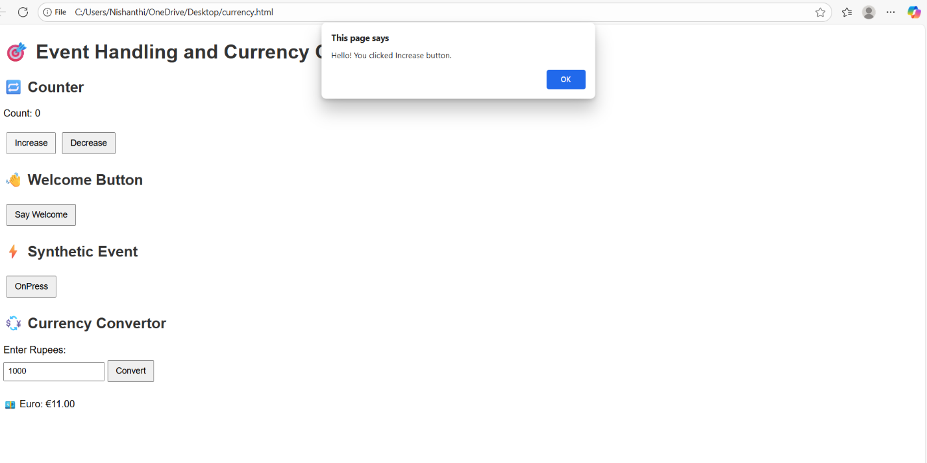

**When pressing decrease button(Count value from 0 t0 -2 after pressing 2 times)**

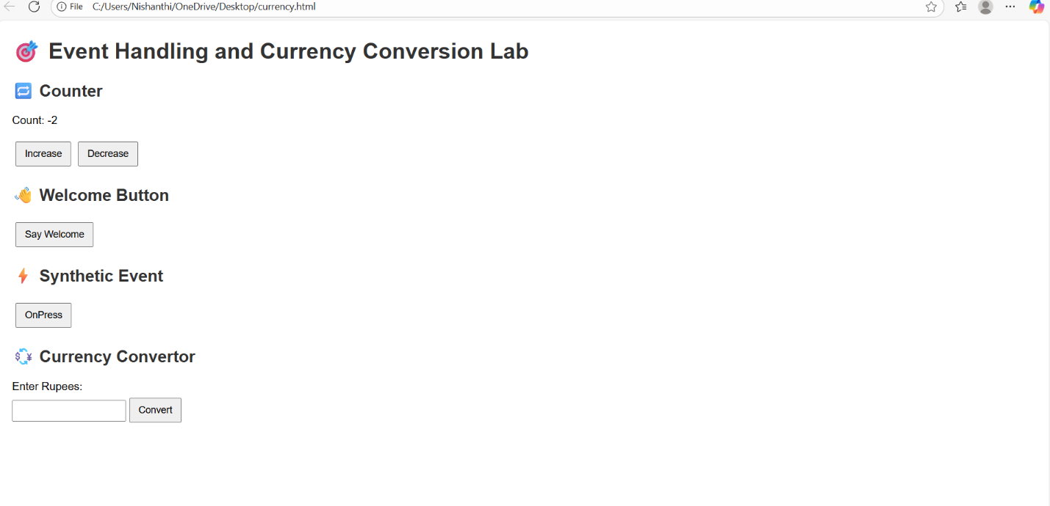

**When pressing welcome button**

**When clicking Onpress synthetic event**

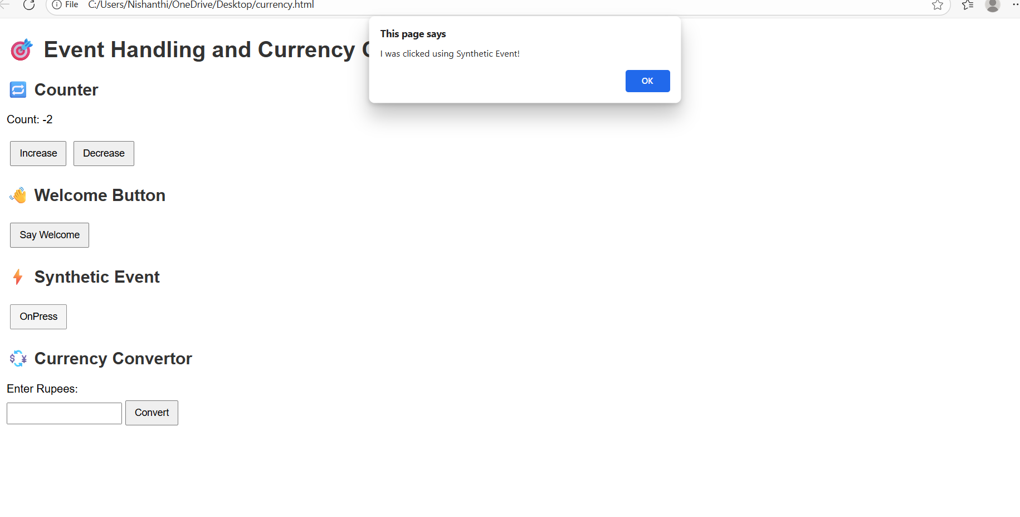

**When giving value in rupees and pressing convert button**

**Currency conversion**

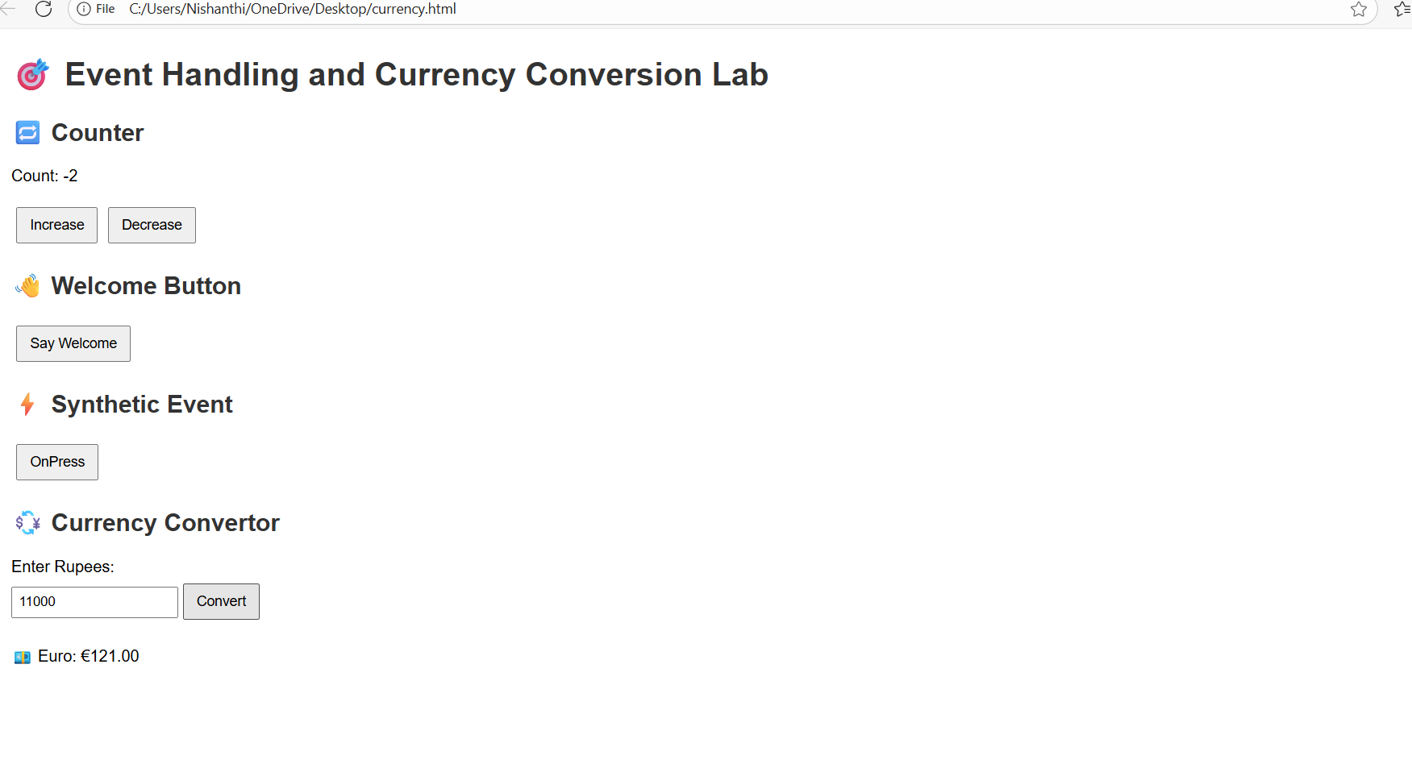

**4)(ReactJS-HOL 12) React Conditional Rendering Lab: Flight Ticket Booking Based on Login State**

**File name:App.js**

import React, { useState } from 'react';

function GuestPage() {

return (

<div>

<h2>Welcome Guest ✈️</h2>

<p>You can only browse flight details. Please login to book tickets.</p>

</div>

);

}

function UserPage() {

return (

<div>

<h2>Welcome User 👤</h2>

<p>You are now logged in. You can book tickets.</p>

</div>

);

}

function App() {

const [isLoggedIn, setIsLoggedIn] = useState(false);

let content;

if (isLoggedIn) {

content = <UserPage />;

} else {

content = <GuestPage />;

}

return (

<div style={{ textAlign: 'center', padding: '20px' }}>

<h1>🎟️ Flight Ticket Booking App</h1>

{/* Conditional Button */}

{isLoggedIn ? (

<button onClick={() => setIsLoggedIn(false)}>Logout</button>

) : (

<button onClick={() => setIsLoggedIn(true)}>Login</button>

)}

<hr />

{/* Conditional Rendering */}

{content}

</div>

);

}

export default App;

**Output:**

**Before logging in**

**After logging in**

**5)(ReactJS-HOL 13) Conditional Rendering in React with BloggerApp: Books, Blogs & Courses**

**File name:App.js**

import React, { useState } from "react";

import BookDetails from "./BookDetails";

import BlogDetails from "./BlogDetails";

import CourseDetails from "./CourseDetails";

function App() {

const [page, setPage] = useState("books");

let content;

if (page === "books") {

content = <BookDetails />;

} else if (page === "blogs") {

content = <BlogDetails />;

} else {

content = <CourseDetails />;

}

return (

<div style={{ textAlign: "center", padding: "20px" }}>

<h1>📚 BloggerApp - Books, Blogs & Courses</h1>

{/* Button group */}

<div>

<button onClick={() => setPage("books")}>Books</button>

<button onClick={() => setPage("blogs")}>Blogs</button>

<button onClick={() => setPage("courses")}>Courses</button>

</div>

<hr />

{/* Render selected component */}

{content}

</div>

);

}

export default App;

File name:BookDetails.js

import React from "react";

function BookDetails() {

const books = [

{ id: 1, title: "React Explained", author: "Zac Gordon" },

{ id: 2, title: "Eloquent JavaScript", author: "Marijn Haverbeke" },

];

return (

<div>

<h2>📖 Book List</h2>

<ul>

{books.map((book) => (

<li key={book.id}>

<strong>{book.title}</strong> by {book.author}

</li>

))}

</ul>

</div>

);

}

export default BookDetails;

File name:BlogDetails.js

import React from "react";

function BlogDetails() {

const blogs = [

{ id: 1, title: "Learning React", views: 2500 },

{ id: 2, title: "Understanding JSX", views: 1500 },

];

return (

<div>

<h2>📝 Blog List</h2>

<ul>

{blogs.map((blog) => (

<li key={blog.id}>

{blog.title} -{" "}

{blog.views > 2000 ? "🔥 Popular Blog" : "👍 Regular Blog"}

</li>

))}

</ul>

</div>

);

}

export default BlogDetails;

File name:CourseDetails.js

import React from "react";

function CourseDetails() {

const courses = [

{ id: 1, name: "React Basics", enrolled: true },

{ id: 2, name: "Advanced JS", enrolled: false },

];

return (

<div>

<h2>🎓 Course List</h2>

{courses.map((course) => (

<div key={course.id}>

<p>

{course.name}{" "}

{course.enrolled && <span style={{ color: "green" }}>✅ Enrolled</span>}

</p>

</div>

))}

</div>

);

}

export default CourseDetails;

**Output:**

**Booklist**

**Bloglist**

**Courselist**

